Regard to the message “the BT download stop running, please contact the admin”.

It is caused of the BT server is Stop. Please start it.

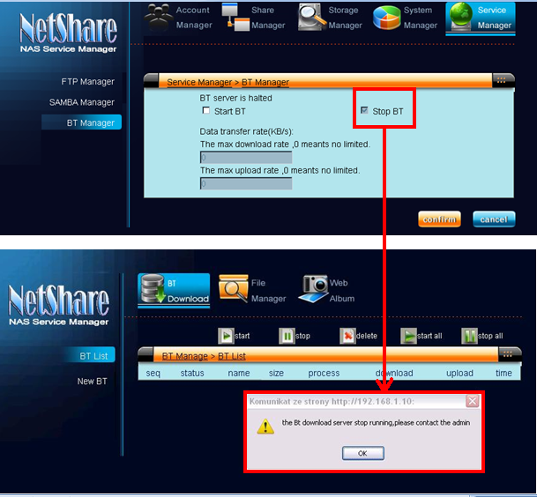

As below is the BT download test. We download 4 BT files, and the tasks are all finished except that one of them is downloading.

* Please make sure that the firmware version is updated to 2009-10-05.

