Instrukcja obsługi
Techtop USB-P1 Telefon VoIP na USB

Rozdział I
Wprowadzenie
1.1 Wstęp
Słuchawka telefoniczna na USB. Efektywne rozwiązanie dedykowane dla użytkowników komunikatora Skype.
1.2 Specyfikacja:
1. wsparcie dla Skype i SIP, H.323, MGCP,
2. wyświetlacz graficzny LCD,
3. wbudowany głośnik,
4. wysoka jakość dźwięku,
5. interfejs USB,
6. sygnalizacja dźwiękowa połączeń przychodzących,
7. redukcja efektu echo i szumów,
8. tryb full duplex,
9. identyfikacja numeru przychodzącego VoIP,
- 199 numerów wybieranych i odbieranych w pamięci telefonu,
- wbudowana karta dźwiękowa,
- zasilanie z portu USB, nie wymaga zewnętrznego źródła zasilania,
- wsparcie dla aplikacji: Netmeeting /Messenger, Mediaring, Net2phone, Dialpad.
1.3 Wymagania systemowe
- PⅡwith 200 MHz CPU or better with USB interface
- 64MB of RAM
- 10MB or more hard disk space
- Operating System: Windows 98/ME/2000/XP
- Network: LAN, ADSL, ISDN, 33.6K modem or better
1.4 Package Contents
- USB-P1K x1
- User Guide x1
- Installation CD x1
2

CHAPTER 2
Use of USB-P1K
2.1 Run Skype
Download Skype software and install it
(www.skype.com), the version must be 1.0.0.106
or higher.
Run Skype and log in with skype account.
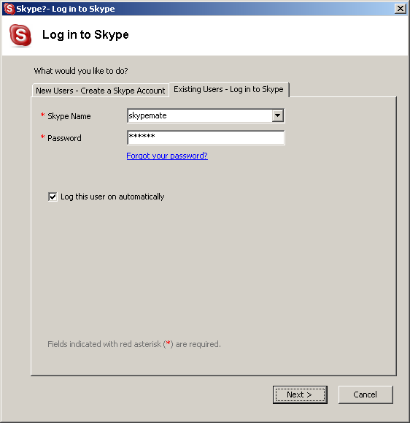
3
You can create a Skype account as shown below:
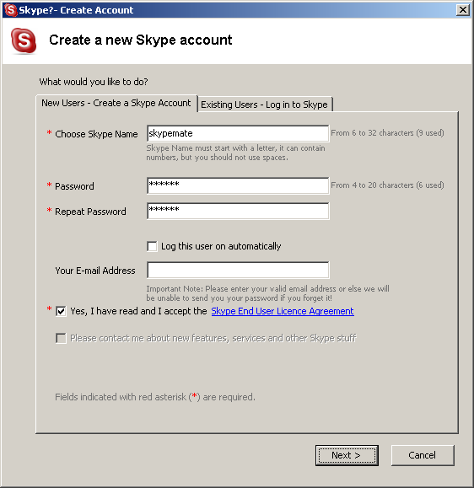
After the software startup, the icon will appear to the system tray as shown below:
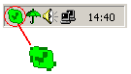
4
That indicates the Skype has successfully connected to Internet. If it hasn’t connected to Internet, the icon will be shown as , now you have to check whether PC is connected to Internet successfully or not.
2.2 Connect USB-P1K to PC
Connect USB-P1K to PC , the LCD shows "VOIP- Phone".
2.3 Run SkypeMate
Download SkypeMate software and install it (www.tech-top.com or www.skype-phone.net )
Run SkypeMate
Double-click the icon  on the desktop, the Skype program will pop up the window as shown below:
5
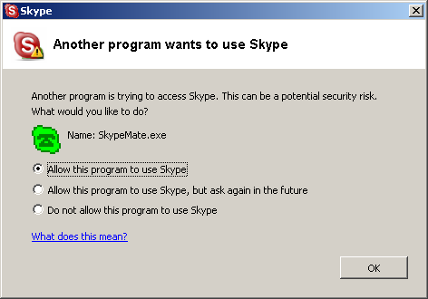
Select the first item “Allow this program to use Skype”, click “OK” button.
Note: If you selected the wrong item, you can execute “File->Options-> Privacy-> Manage other programs’ access to Skype->Change->OK” to open the window as above to make another selection.
6
After running SkypeMate, the icon will appear to the system tray as shown below:
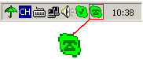
That indicates the device and Skype are connected successfully.
If the icon shown as , please run Skype first.
If the icon shown as , it means USB-P1K connected incorrectly, please reconnect USB-P1K to PC.
2.4 Call another Skype user (PC to PC)
Add "skypemate" to Contacts
Assign Speed-Dial for it, example "11"
7
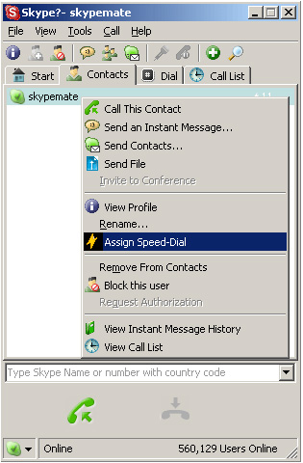
Input number and call out:
Press digital "1" and "1" on USB-P1K, this number will be shown on Skype window, then press SEND key  on USB-P1K to call out.
8
2.5 Call to regular phone (PC to Phone)
Press "00"+"country number" + "phone number", then press .
Example: call to China, beijing, press 00861012345678, then press SEND key.
0086 10 12345678
--------------- ----------- -------------------
country code city code destination number
Note: If you want to use this function, you should buy SkypeOut Credit first.
2.6 Answer a call
When a call in, the USB-P1K is ringing, press to answer the call, press  to refuse the call.
2.7 Adjust options (Volume and Ringer)
Double-click the  on the taskbar, then you can
adjust the volume and ringer.
9
2.8 Function keys
IN: Caller number review, delete and redial
You can press “IN” button to review the caller numbers with the time and date. Press “IN” button repeatedly to review the caller numbers from the latest memory to the oldest memory round by round. While you are reviewing, you can double-click “C” button to delete this number or press SEND key to call out.
OUT: Out number review, delete and redial
The usage is similar to “IN” button.
C: Delete phone number and input wrong number
(1) Double click to delete caller number or out number.
(2) Delete the input wrong number while you are dialing number.
▲: UP
10
Review caller number or out number from oldest to latest.
▼: DOWN
Review caller number or out number from latest to oldest.
2.9 FAQ

Problem 1
The voice is played from the PC’s sound card instead of the USB-P1K when I make/answer a call?

Resolution
Open the Main window of Skype, click on “File-> Options”, and go to the table Hand/headsets, set Audio In, Audio Out and Ringing to the USB Audio Device.
11
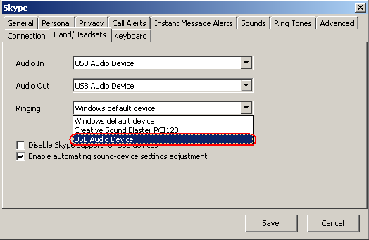
Problem 2
There is no voice comes out when play music?

Resolution
Please execute the “Control Panel->Sound and Video ()->Audio”, set Sound Playback and Sound Recording’s Preferred device to your sound card, it shown as below:
12
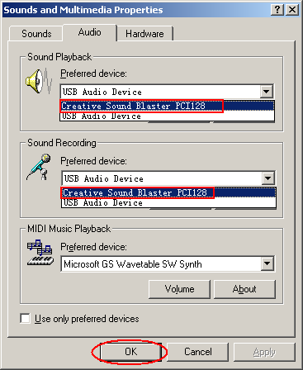
Problem 3
Skype has been startup, but the icon of SkypeMate still shown as ?
Resolution
Please see 2.3 Run SkypeMate for detail.
13

Problem 4
When you minimize the Skype windows, Skype will exit?

Resolution
Execute “File->Options->Hand/Headsets” to open the windows as below:
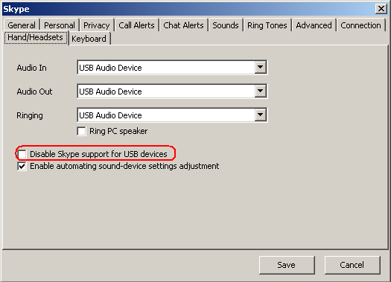
And don’t select the check box before “Disable Skype support USB devices”.
14
2005-3-29 Ver.2
2005-3-29 Ver.2

