B1080PX-5
Jan 25, 2012
3453509
QUICK GUIDE
1. Hardware Overview
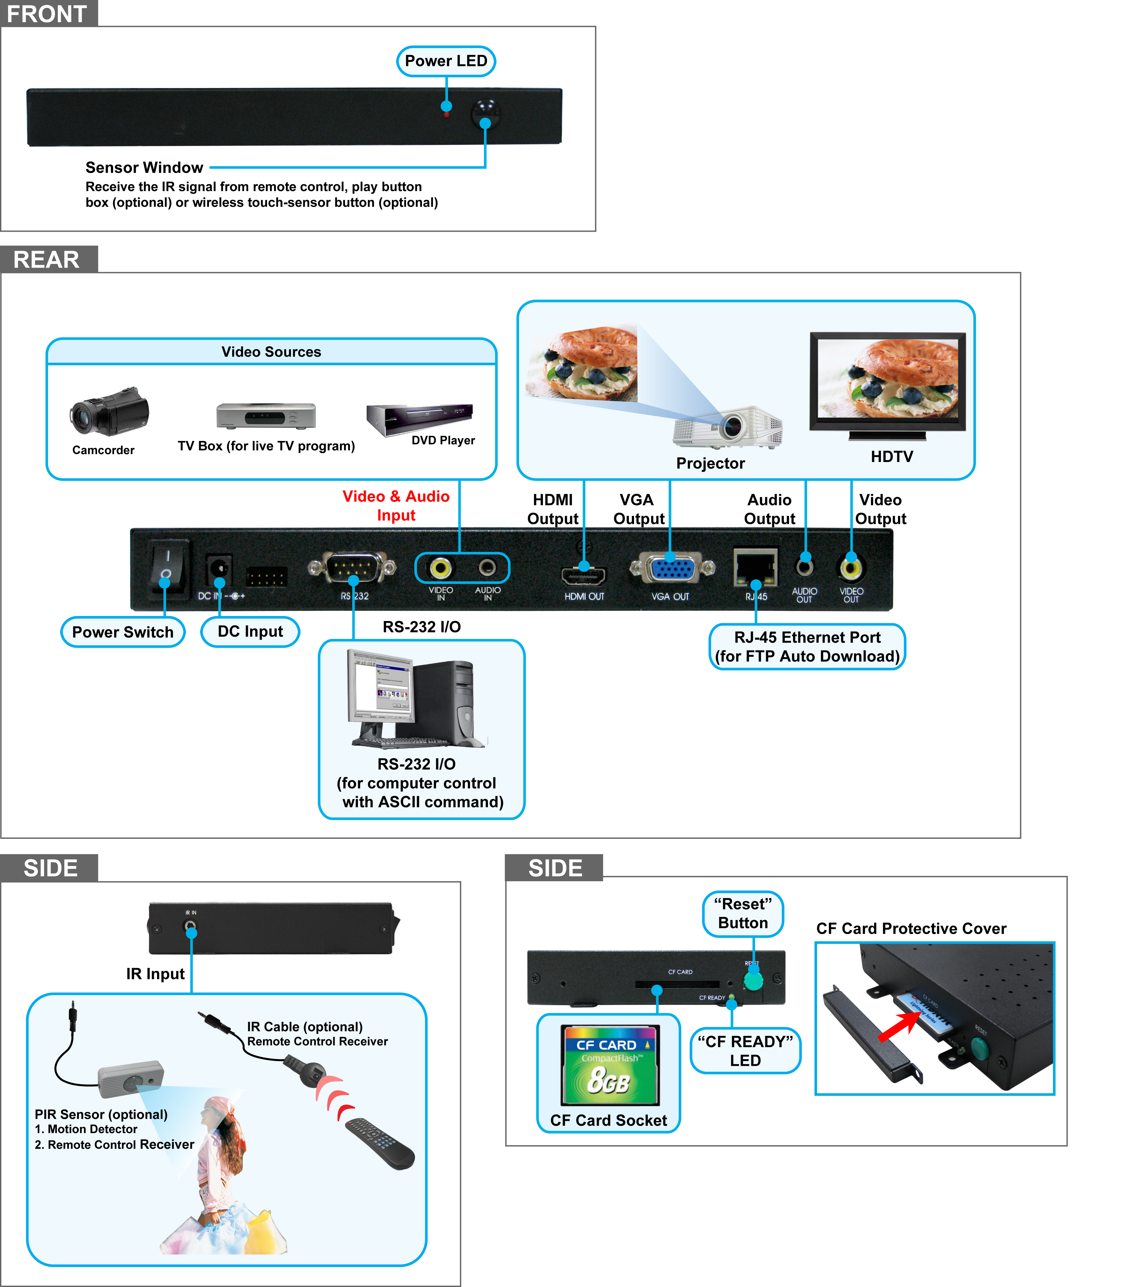
- Power Switch: Toggle between main power on & off.
- DC Input: For the power adapter. (DC 12V / 1.5A)
- RS-232 Connector: Used for computer control with ASCII command.
- Video & Audio Input: Connects to video sources (TV Box or DVD player).
- HDMI Output: Connects to devices that support HDMI input.
- VGA Output: Connects to devices that support VGA input. (LCD、projector)
- RJ-45 Ethernet Connector: Connects to router or PC by RJ-45 Cable.
- Audio Output: Connects to sound input. (HDTV with amplified speaker)
- Video Output: Connects to devices that support Video input. (HDTV、projector)
- IR Input: Connects to optional PIR Sensor or optional IR cable.
- “CF READY” LED: Steady green confirms that the CF card is inserted correctly.
- CF Card Socket: For CF memory card.
- “RESET” Button: To restart the B1080PX-5.
2. Network Setup
Confirm the B1080PX-5 is already connected to the network.
  - Setting the Network from the OSD Menu
Step1: In the main menu, using the “▼” button on remote control to select the “SETUP” item, and then press the “ENTER” button. You will be presented with the B1080PX-5 settings screen.
You can also press the “SETUP” button on remote control to directly open the settings screen. (If there is file that is being play, please stop first.)
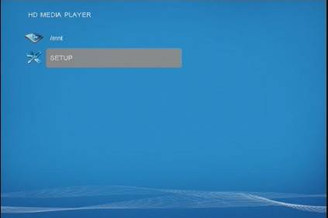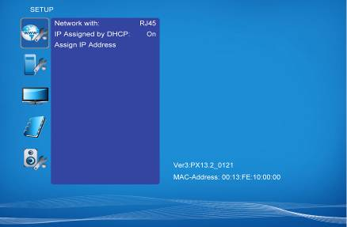
Step2: There are five groups of sub-menu in the main menu (“Network Setup”, “FTP Setup”, “Video Setup”, “Other Setup” and “Scrolling Setup”).

Step3: In the Network Setup item
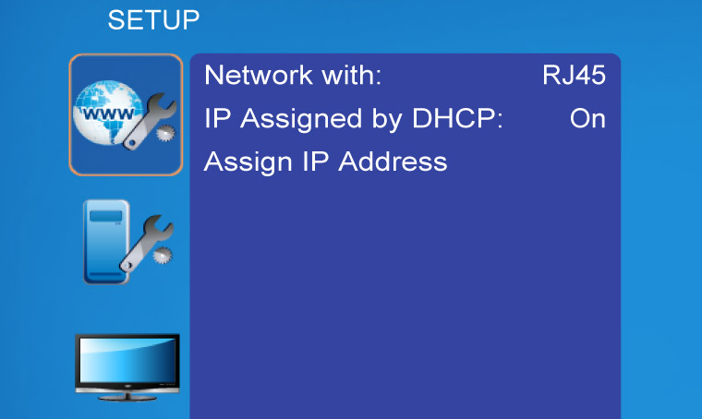
- Network with: Select your network connection Disable/ RJ45.
- IP Assigned by DHCP: If you have a DHCP-enabled router, please select “On”, and then the router will automatically assigns an IP address to the B1080PX-5. If you don’t have a DHCP –enabled router, select “Off” and type the network information in “Assign IP Address”.
- Assign IP Address: If the B1080PX-5 is connected to a network without a DHCP server or you want to use Local FTP Server function, enter the fixed IP address, Mask, Gateway and DNS for the B1080PX-5.
Step4: After finish setting, press the Setup button to save and quit.
2.3 Install PopCenter
Step1: Insert the driver CD into your CD-ROM drive, then the autorun function will start up the shell program. If the autorun window does not display, please execute the Autorun.exe program to bring out the autorun screen.
Step2: Click on the Install Pop Center to install the remote management software (POP Center).
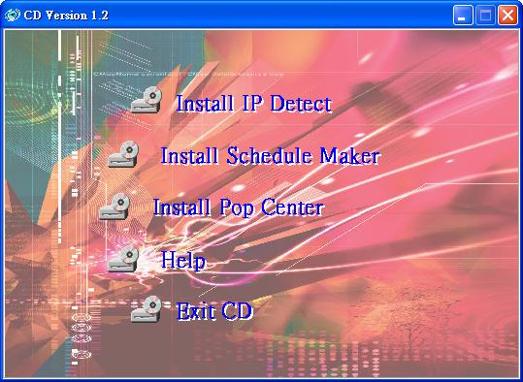

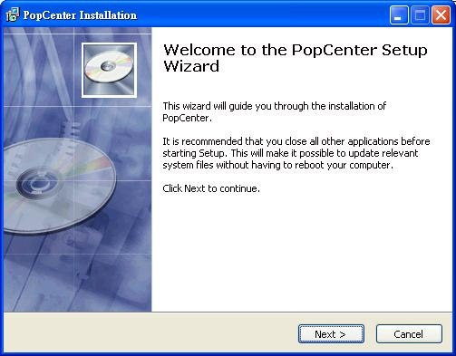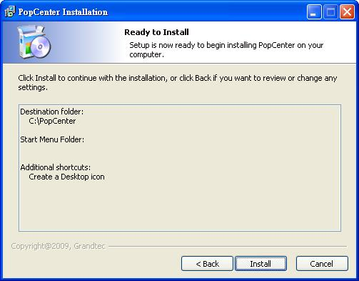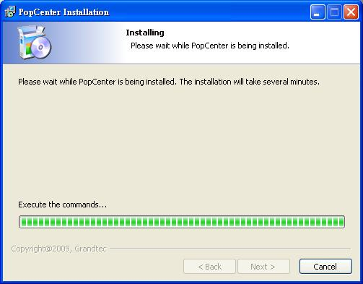
click Next to continue

click Install to start the installation

Installing

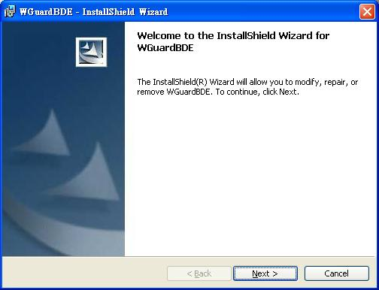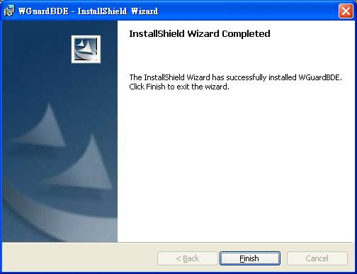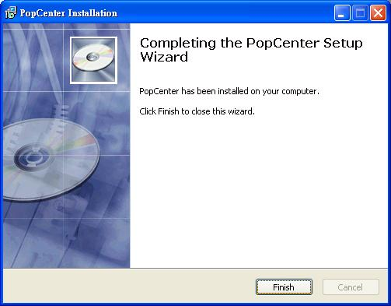
click Next button to install WGuardBDE
click Finish button to complete WGuardBDE installation
click Finish button to complete PopCenter installation

Step3: After installing the Pop Center software, the “Pop Center” icon should appear on your desktop. Or you could also find the shortcut by click on < Start > → < Programs > → < PopCenter >.
2.3 Quick Connect by using PopCenter
Step1: Double click on the POP Center’s execution file on Windows Desktop or in the PopCenter folder of the Start menu. When the program is executed, the following screen will appear.
Step2: There is a button: “Search Devices”, Please click this one. And you can find all devices under your local Ethernet.
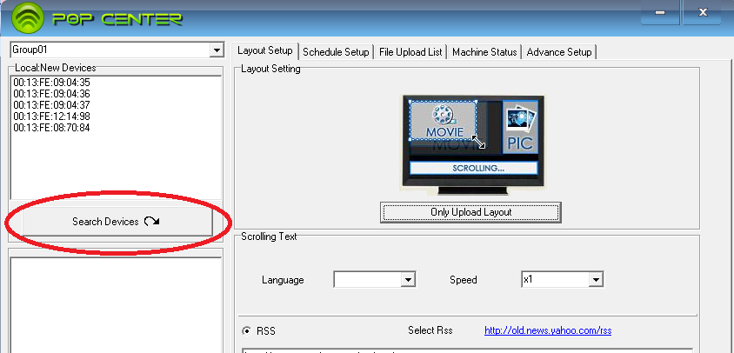
Step3: Please Double Click to add to this group ”Group01”.:

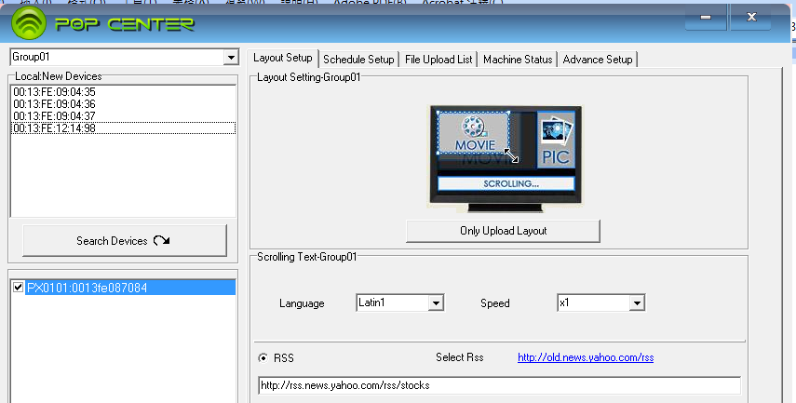

- There are six tabs in the tab menu: “Advance Setup”, “Layout Setup”, “Schedule Setup”, File Upload List”, and “Machine Status”.
Step4: Please select “Schedule Setup”
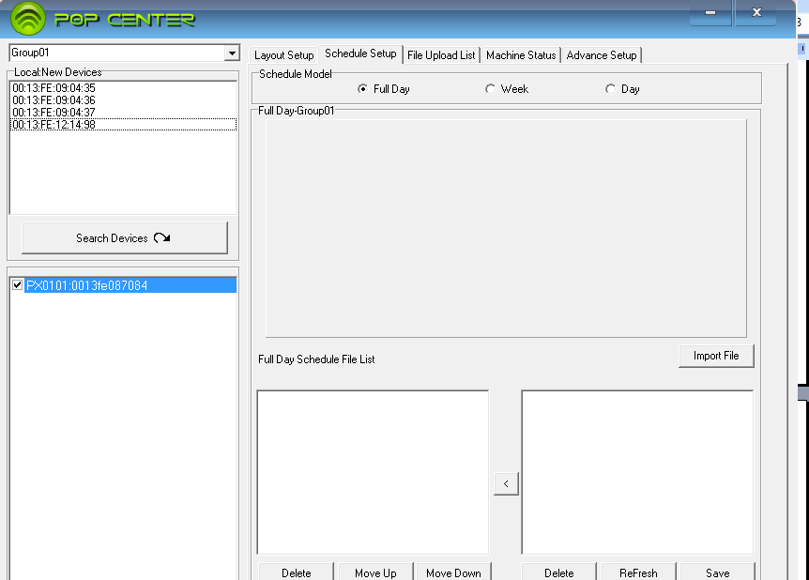
Step5: Please click “Import File” to import a movie
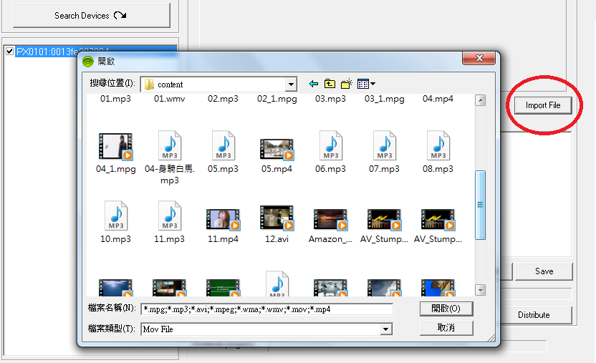
Step6: Please choice a file to Full Day Schedule File List, then Click Distribute
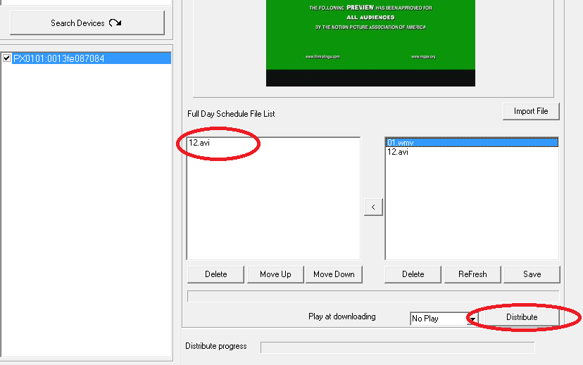
Step6: Make sure and check those files will be uploaded. by those machines which you selected under this Group.
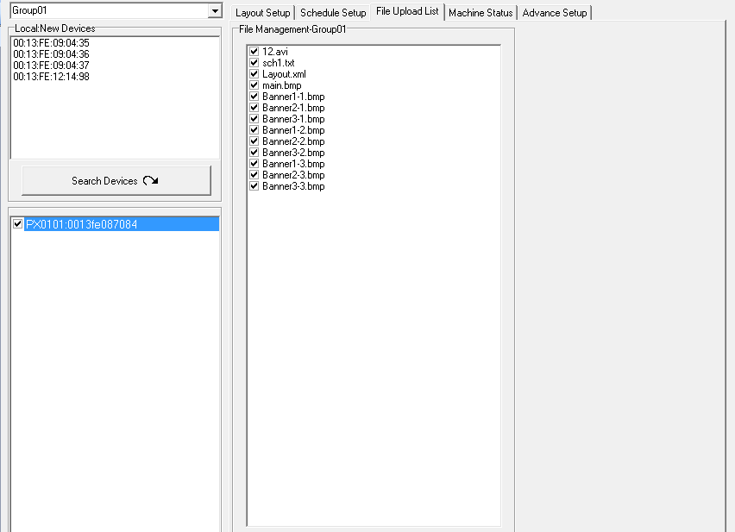

Step7:Replace Time: Set the time to restart the B1080PX after finish downloading (replace the downloaded files).
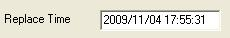

Step8: Apply Button: Press the Apply button to create the dmac.txt file in the FTP server automatically, and the B1080PX will check the file at the specific time.
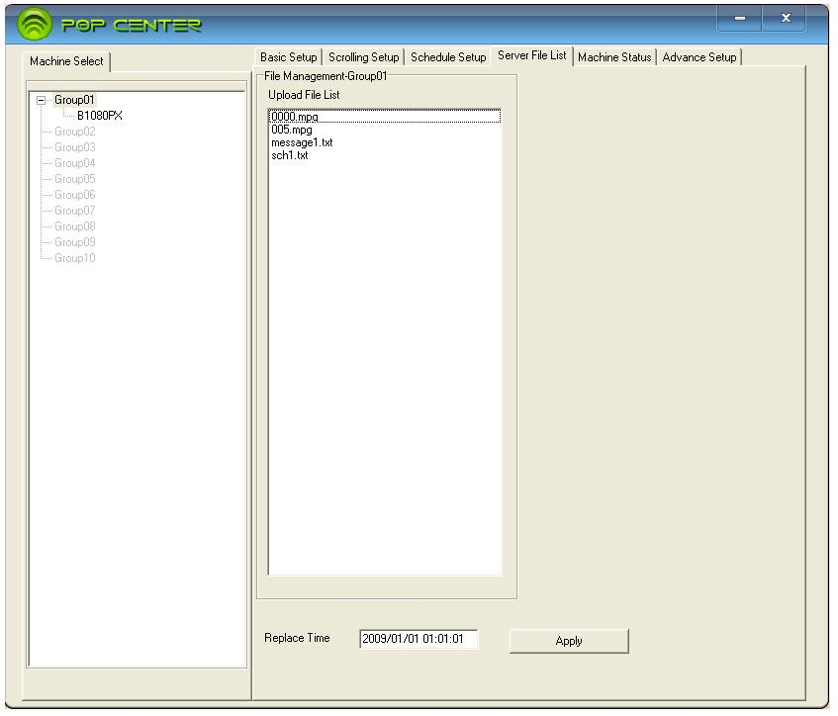
2.3 Machine Status

- Auto Update Machine Status: Display the connected B1080PX status. Select “Yes” to enable the function.
- Light Define
- Play: The B1080PX is playing.
- Download: The B1080PX is downloading.
- Play/download: The B1080PX is playing and downloading simultaneously.
- Stop: The B1080PX is stopped.
- Disconnect: Network connection error.
- Disable: The B1080PX is not set yet.
- Group01
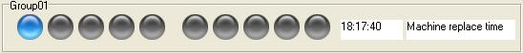

PS. Please consult the B1080PX-5 manual on Driver CD for more detail.

