Userful multiplatform user manual

Step1 | Must Check your Server  1: CPU must support 64bit and the Virtualization  2: The Server Video must be Support on userful 是说服务端的视频格式必须支持Userful吗？  3: More than 30G Disk is recommended.  4: Internet network is available for software update  5: Software cannot be installed by usb-dvdrom, shall be installed by SATA/IDE dvd rom  6: a switcher or router is required;  7: AMD CPU is not recommended.
Step2 | Step by step , Reboot  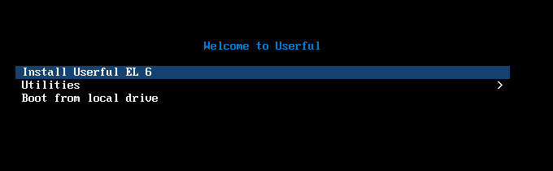  Set Administrator and Password: set root/111111  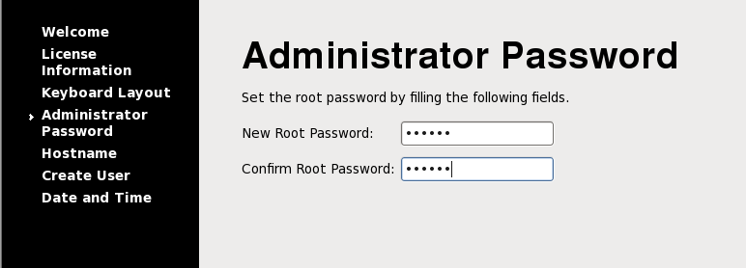  Set user and Password, set centerm/111111  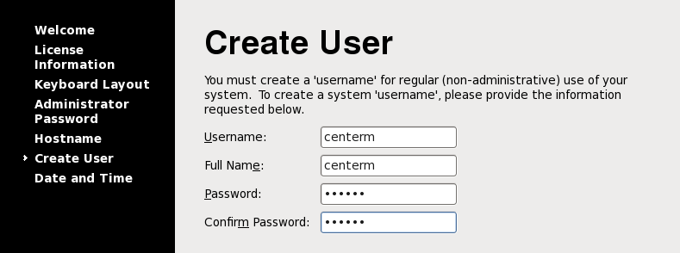
Step3 | Update useful package should be performed with a root user, root account and password shall be required;  Installing external packages will take 10 mins or more  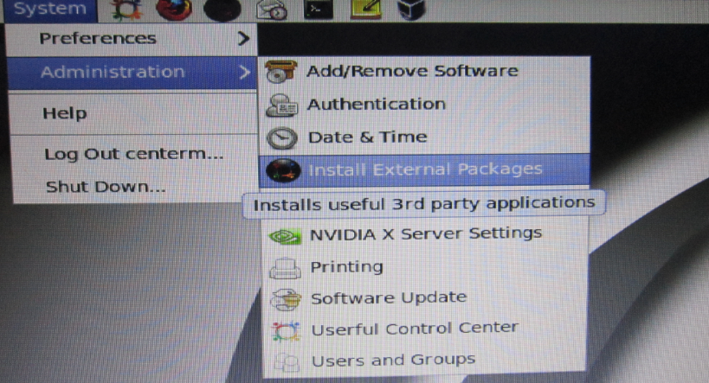  After installed, reboot, and login centerm/111111 user mode
Step4 | At user mode (centerm/111111)  Run “Control center”, input 111111( user password)  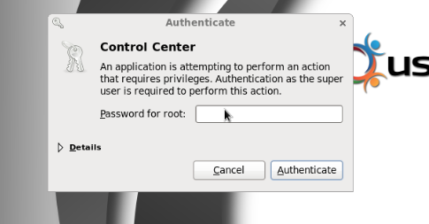
Step5 | The zero client centerm logo  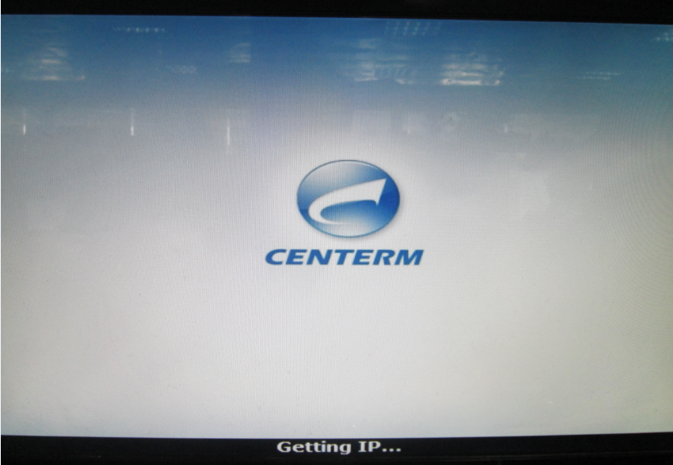  The Server Search the Zero Client，and set zero client ip mode (dhcp or static)  Then, Assgin All  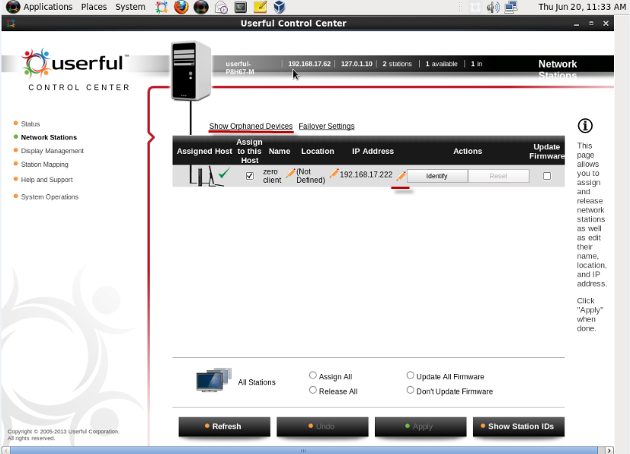
Step6 | Run virtual box, install xp , win7 or other OS  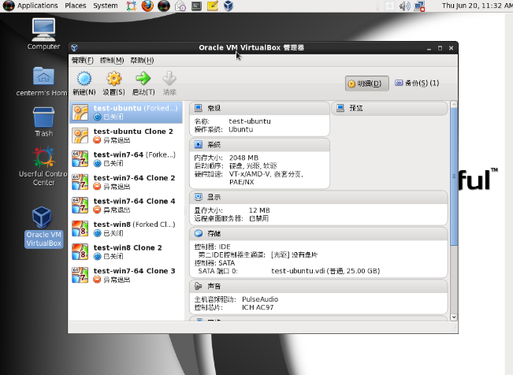
Step7 | - The userful multiplatform linux have some functions, the important functions is sharing linux and userful-virtual box vdi (need have virtual box vm os)  Create Profile  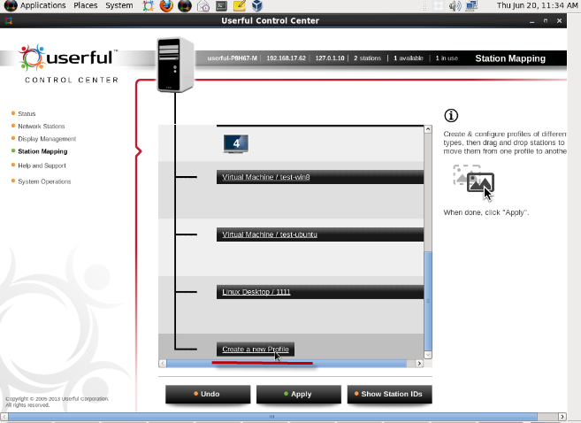  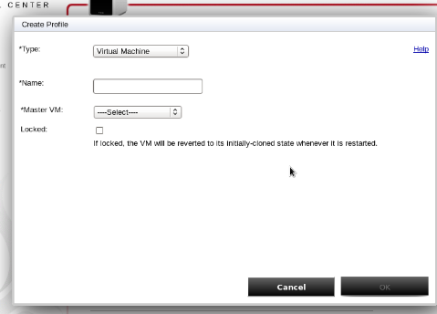  - Set Station Mapping to Profile ( drag 2/3/4 station id to prolife, canot drag ID1) ,Apply  - 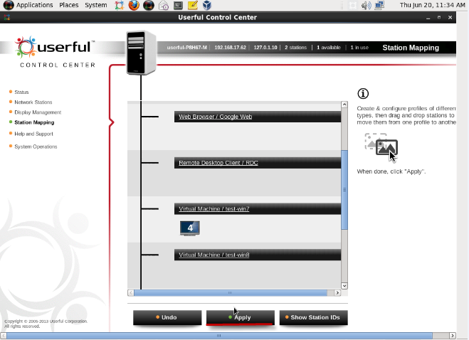
Step8 | The Zero client then first show userful logo, , and next show OS  