QUICK INSTALL GUIDE –HARDWARE

UCR-525
Internal 6-in-1 Card Reader build-in USB and 1394 extension Port

Hardware Installation
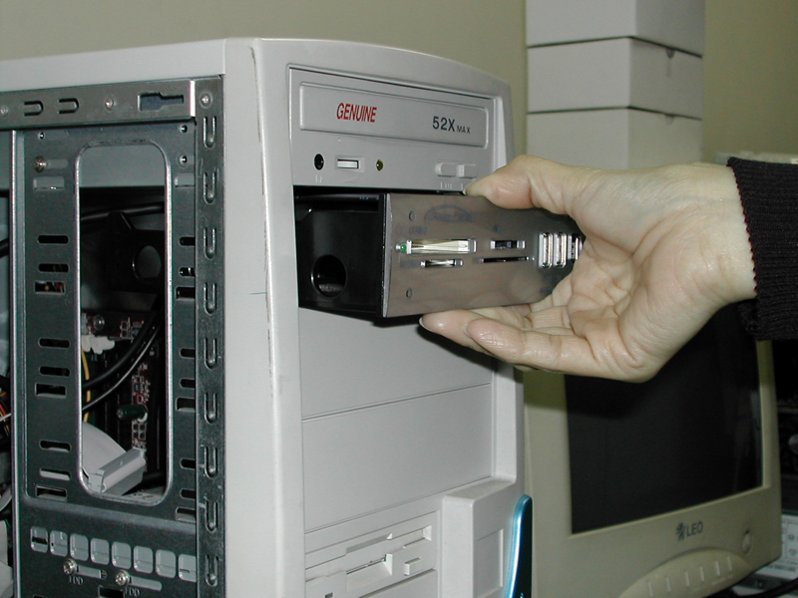
Step 1.
Please put this product in front of the computer.

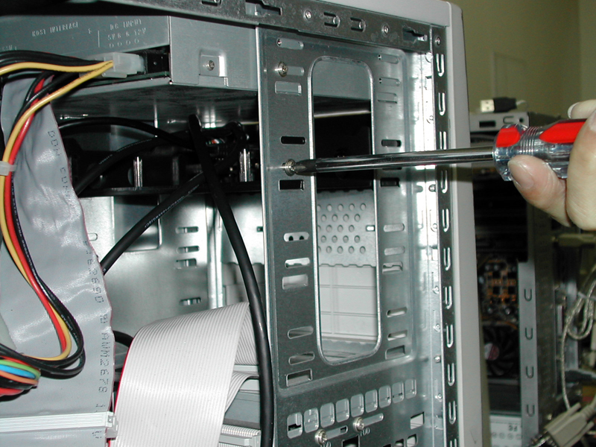
Step 2.
Please fasten the screws on both sides
to fasten the panel.

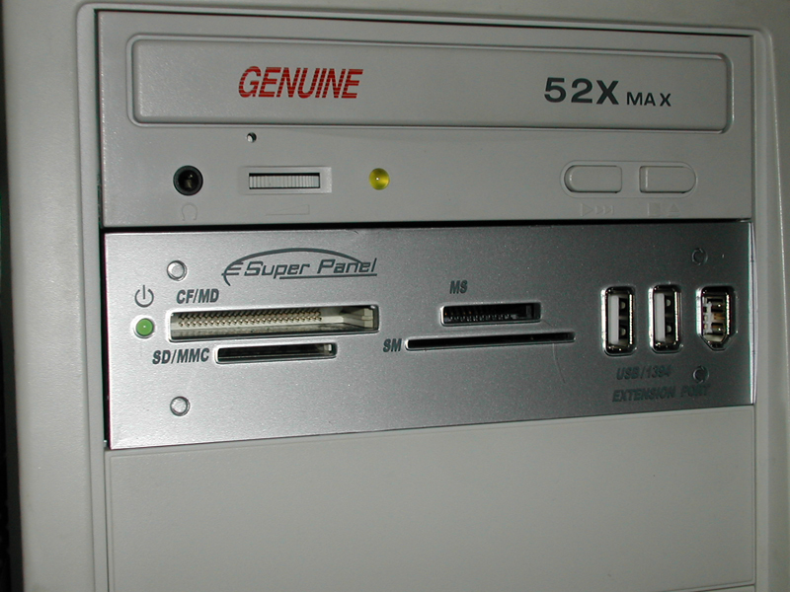
Step 3.
Connect 1394 and USB cable to your motherboard’s
(add-on card’s) 1394 and USB port.

Step4.
Make sure all 1394 and USB cable’s signal
pins that were connected to the correct pins of
motherboard.

Connect the USB Cable
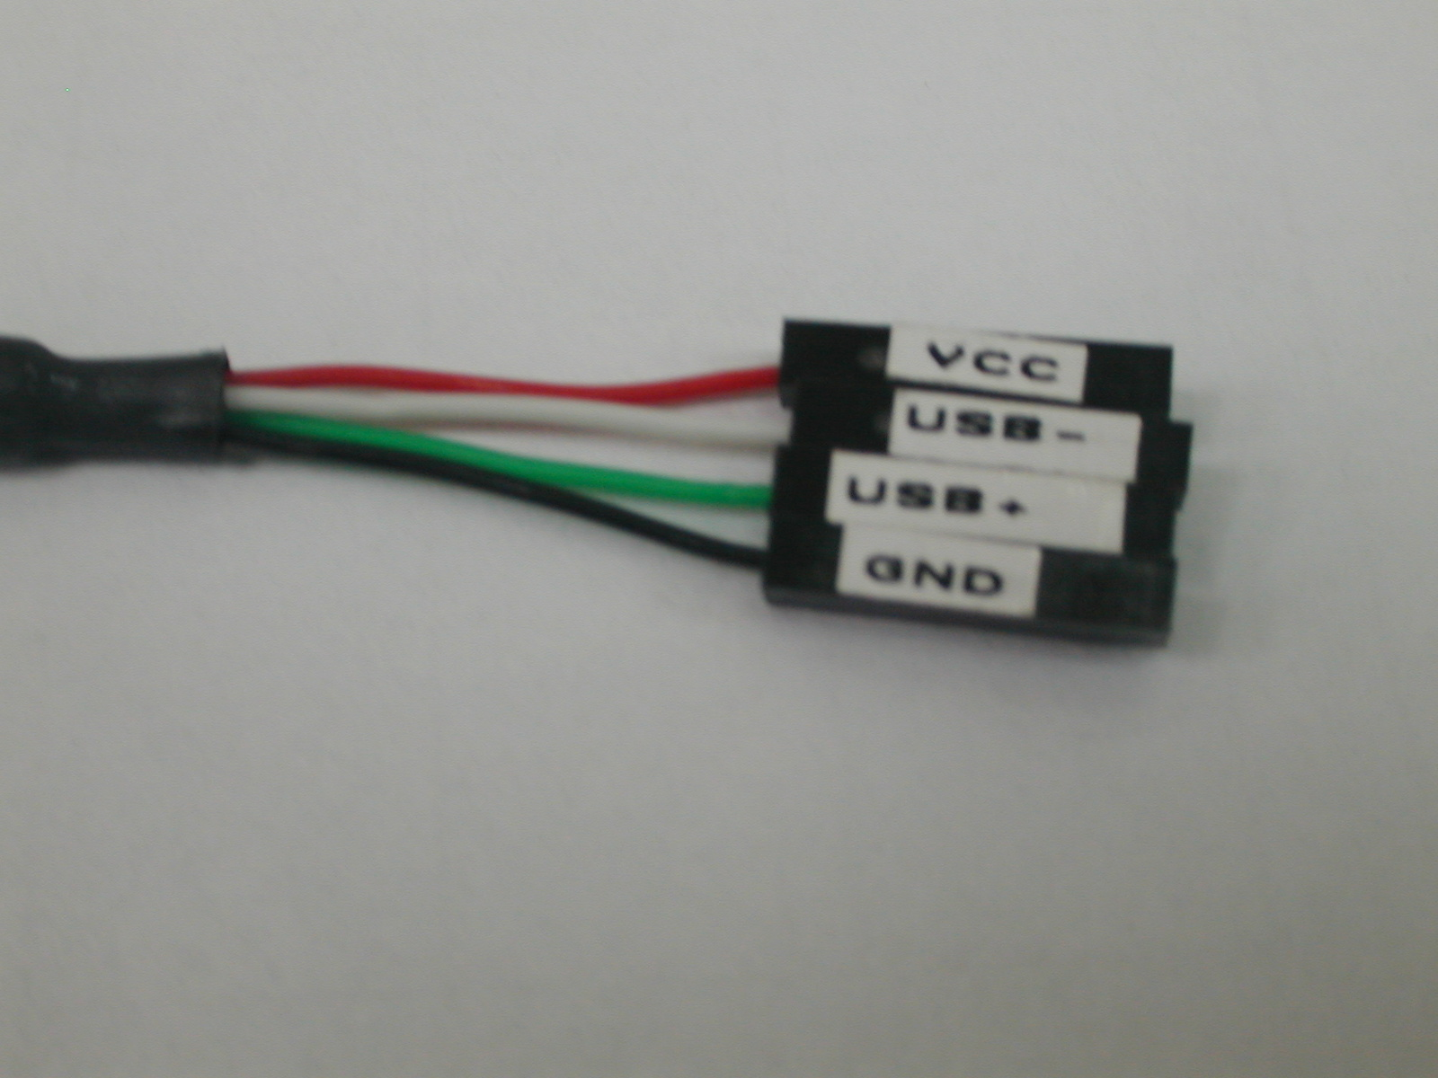
Color | Signal
Red | VCC
White | DATA -
Green | DATA +
Black | GND

Caution
Please don’t be confused the [VCC] and [GND] hose pin, otherwise you will burn down the hardware.

QUICK INSTALL GUIDE -DRIVER
UCR-525
Internal 6-in-1 Card Reader build-in USB and 1394 extension Port

Driver Installation
Windows XP/ME/2000(SP3)
Windows XP/ME/2000(SP3) users DO NOT need to install drivers.
Windows will automatically provide a USB 2.0 devices driver for this 6-IN-1 Card Reader under USB2.0 Host Hosing on the motherboard.

WIN98SE/2000

Step1. Please put the CD driver into the CD-ROM. Step5. Via this step, press “Next”
Step2. Execute “SETUP.EXE” for installation
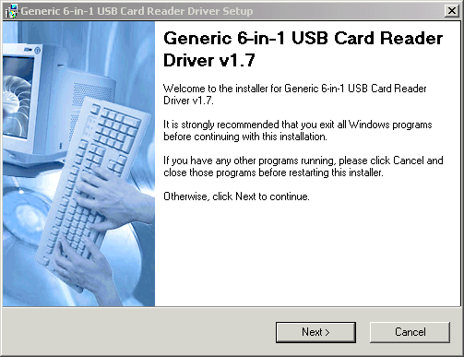
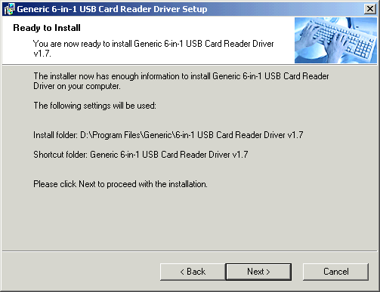

Step3. Choose “English”, then click “Next”buttom. Step6. Click “Finish”
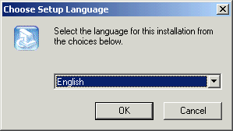
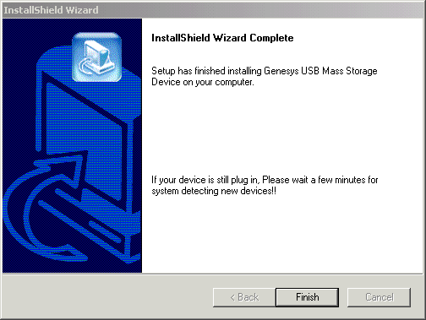

Step4. Click “Next”
