Chapter 1 Welcome to Grand RF CMOS USB
( 2.4 GHz Wireless Audio/Video Transmitter and Receiver with USB Video Capture )

1.1 Introduction
Grand RF CMOS USB is a wireless audio & video transmitter and receiver with a 1/3” color CMOS video camera and microphone integrated into the transmitter. It includes a stand that can be mounted on the wall or ceiling. Grand RF CMOS USB can delivers images and audio close to 100 meters in open area ( 30 meters through walls and floors). With the video capture function, it can capture both still & full motion video (.bmp & .jpg file). It is the bridge between your analog video source (VCR, analog camera, camcorder) and your computer. The hardware CAPTURE let you capture the image instantly. The Grand RF CMOS USB is not only ideal for home security, room and child monitoring. It also can be apply to video capture, image capture, video conference and video fun.

1.2 Features
- Supports RCA Video IN, S-Video IN & stereo phone jack Audio IN.
- Built-in microphone for audio monitoring.
- Four channels available for best quality selection.
- View or record the image on TV, VCR/VCD/DVD player or computer with video capture function.
- When you connect a RCA cable to the Video IN of receiver , it will replace & disconnect the remote input video signal (Tx).
- It is the best for application on Entertainment/Attendance/Surveillance & market on DIY, SOHO & Security.
- Bundle with security software (optional).
- Support Windows 98/Me/2000.

Transmitter
- 2.4~2.483 GHZ frequency range: CH1=2410 MHz, CH2=2430 MHz,CH3=2450 MHz,CH4=2470 MHz.
- The world's smallest (1/3") CMOS video camera with built-in 2.4GHz wireless A/V sender.
- 300 TV lines; 300,000 pixels; 3 lux
- Dipole antenna provides optimal video and audio reception
- Supports NTSC or PAL video systems
- The wireless color CMOS video camera pivots 360 degrees on mounting stand for optimal installation
- LEDs for channel indicators
- Built-in microphone.

Receiver
- ISM Band: 2400Mhz ~ 2483Mhz Audio/Video on four selectable channels, CH1=2410 MHz, CH2=2430 MHz, CH3=2450 MHz, CH4=2470 MHz.
- Antenna Mode: Dipole.
- Antenna Port : 50 Ohm PCB Track.
- RF Receiver Current Consumption: Under 450mA.(Typical)
- RF Receiver Sensitivity: -80dbm. (Minimum)
- Dipole antenna provides optimal video and audio reception.
- High speed compression support real time image output.
- Supports following video formats and frame rate with compression:
640 X 480 9 ~ 15 fps  352 X 288 25 ~ 30 fps | 320 X 240 30 fps
640 X 480 9 ~ 15 fps  352 X 288 25 ~ 30 fps | 176 X 144 30 fps
640 X 480 9 ~ 15 fps  352 X 288 25 ~ 30 fps | 160 X 120 30 fps
- TWAIN compatible hardware CAPTURE.

1.3 Specifications
RF CMOS USB Transmitter:
Type Standard | NTSC/PAL
Pick Up Elements | 1/3” color CMOS( Omnivision ) Sensor, 300,000 Pixels
Transmitter Frequency | ISM Band: 2400Mhz ~ 2483 Mhz.  CH1=2410MHz CH2=2430MHz  CH3=2450MHz CH4=2470MHz
Frequency Deviation | +/-100KHz(10℃~50℃)
Demodulation Method | FM.
RF Output Power | Vcc=3.3V, LOAD=50Ω,10 dBm
Antenna | DIPOLE(85mm)
Horizontal scanning  Frequency | NTSC 15.734KHz
Horizontal scanning  Frequency | PAL 15.625KHz
Vertical scanning  Frequency | NTSC 59.94Hz
Vertical scanning  Frequency | PAL 50.00Hz
Resolution | Horizontal 300 Lines
Resolution | Vertical line 300 Lines
S/N ratio | With AGC OFF 46dB
Minimum Illumination | 3 Lux (at F1.2)
Built in | Microphone
Power Source | 6V DC 800mA
Power Consumption | 0.5 W MAX
Operating Temperature | 10℃ ~ 50℃
Dimensions | (L)70mm*(W)58mm*(H)92mm, Anttenna:85mm

Receiver:
Antenna | Dipole
Rx Sensitivity | -80 dBm
Video output | Composite video 1Vp-p
Audio output | RCA-L, RCA-R(1 Vrms)
Power Source | 6V DC 800mA
Operation Temperature | 10℃ ~ 50 ℃
Dimensions | (L)125mm *(W)80mm*(H)35mm,Antenna: 85mm
Receiver Frequency | ISM Band: 2400Mhz ~ 2483 Mhz.  CH1=2410MHz CH2=2430MHz  CH3=2450MHz CH4=2470MHz
Interface | USB V1.1
Video/Audio Source | INT(from RF CMOS Camera)/EXT(Video IN；Audio IN；S-Video
Capture Key | Snap –Shot Key / Software capture
Video Frame | 320 X 240 (30 frames) / 640X480 (12 frames)
Local surveillance | Video out /Audio R/L out
1.4 System Requirement
- OS: Windows 95/98/ME/2000.
- PC with USB port.
- CPU: Pentium-166 MMX or above.
- Sound card: Compatible sound card with MIC driver.
- Display card: support DirectDraw driver.
- Running with 800 X 600, hi-color or true color mode.
- A hard disk with high speed and high capacity.
- CD ROM driver: 4X or above.

1.5 Package Contents
- Grand RF CMOS USB Tx (Transmitter)
- Grand RF CMOS USB Rx (Receiver)
- User’s manual
- Video/Audio cable X1
- Audio cable (for Tx) X1
- S-Video cable X1
- Video cable X1
- Power adapter X 2
- Driver & security application disc
- Battery pack (optional)

Chapter 2 Installation

2.1 Install the Grand RF CMOS USB
Insert the supplied CD into your CD ROM driver
- Connect the supplied power adapter (DC 6V, 800mA) to both Transmitter & Receiver & then set up the channel (4 selectable channels).
- Connect the USB cable of Receiver into the USB port of your PC,
- Connect the video source(as following) to the Receiver.
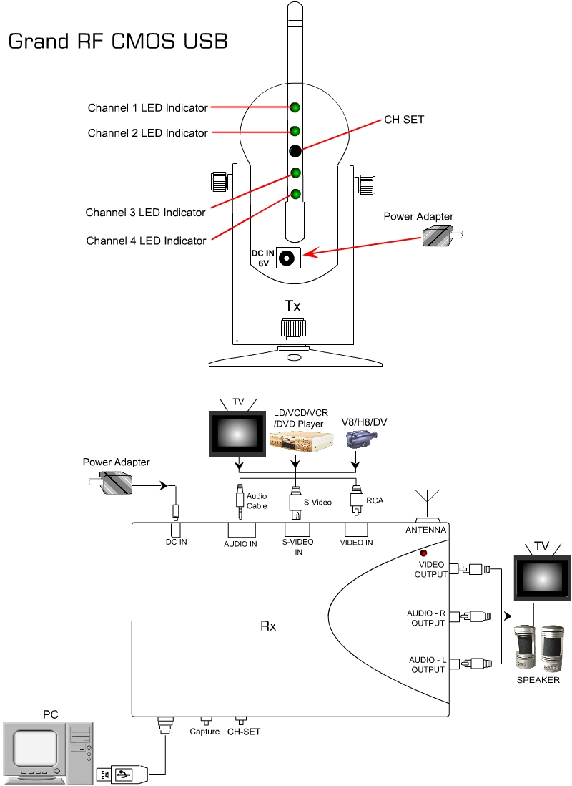
PS: Function Description
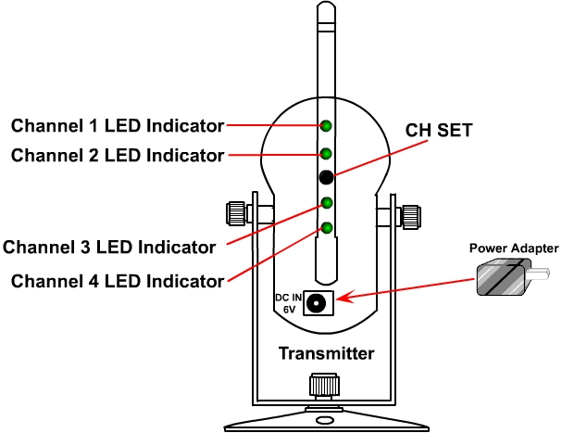
- DC IN 6V: Power connector, connects with the supplied
adapter. Center is positive. (-) ---- ( ---- (+)
- CH-SET : Selects channel that you wish to send.
- ANT (RF-OUT) : Sends Audio and Video signals.
- CH 1 ~ 4 display: Display the working channel that you set up.

- The Windows automatically detect as “USB composite device” and pop up the “Add new hardware wizard”. and click Next button.
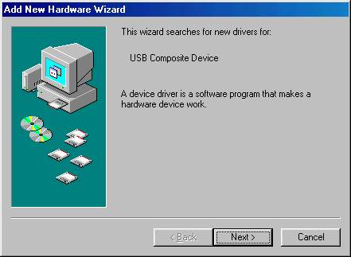
- NOTE : There are 3 devices must be installed. There are 【USB Composite Device】、【Zoran USB Live! Pro Audio Device】& 【Zoran USB Live! Pro Device】.

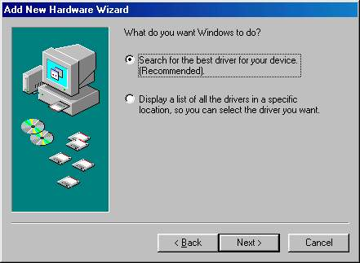
- Check the “Search for the best driver for your device(Recommend).”, then click the Next button.

- Check the “Specify the location”，and type A:\ to specify the device driver location.
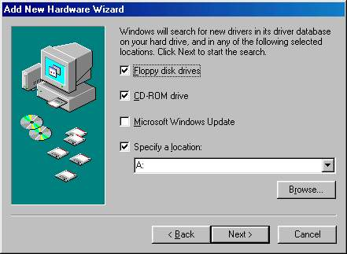
- Please click Next to continue.
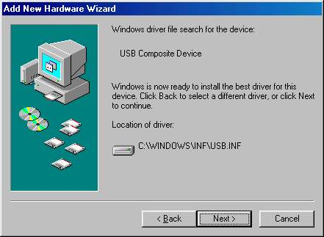
- Please click Finish to complete Setup.
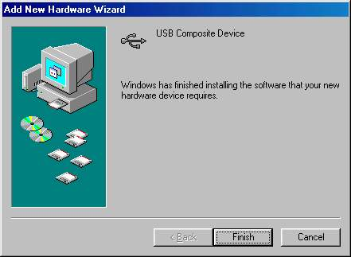

- Using the same way to install the driver for both “Zoran USB Live! Pro Audio device” & “Zoran USB Live! Pro device”.

Chapter 3 Technical Support
When you need RMA or advanced technical service, please fill in this form as detailed as possible and FAX to your dealer or service representative.
Product S/N:
Product Name:
TEL No.: |  | FAX No.:
E-mail address:
Full Address:
Hardware condition:
Mainboard chipset:
Mainboard CPU: |  | CPU clock: MHz
Main memory: MB |  | Cache memory: KB
VGA card: |  | Display memory: MB
Sound card: |  | Hard Disk: MB
Other add-on cards:
Monitor: | Horizontal Freq.: KHz to KHz  Vertical Freq.: Hz to Hz
Problem description:

