F/W UPDATED INSTRUCTION

- Setup IP address:192.168.0.2 manually as the following picture:
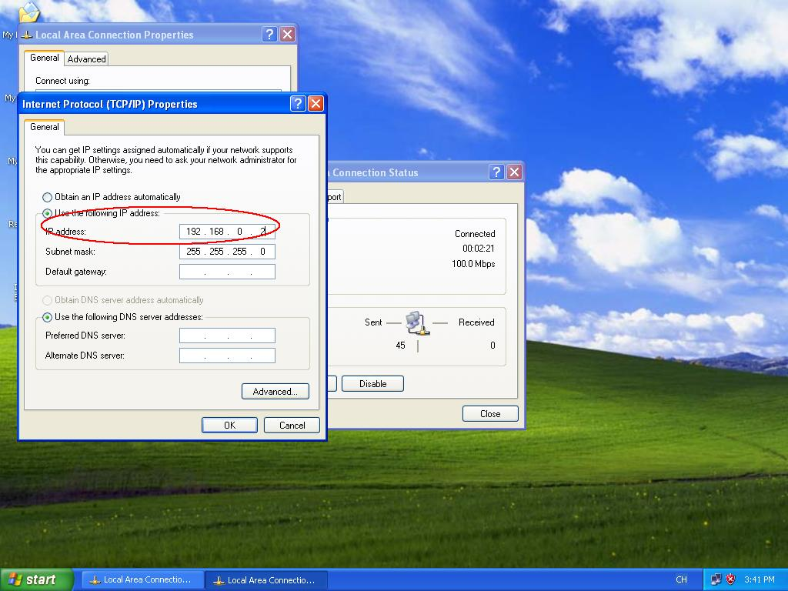

- Connect PC and LAN1 port of Router with RJ45（Notes：it is Router’s LAN1 port）

- Insert the power adapter，meanwhile press the Router’s Reset button for five seconds by the pen point，then input “http://192.168.0.1” in IE, such as the following picture：
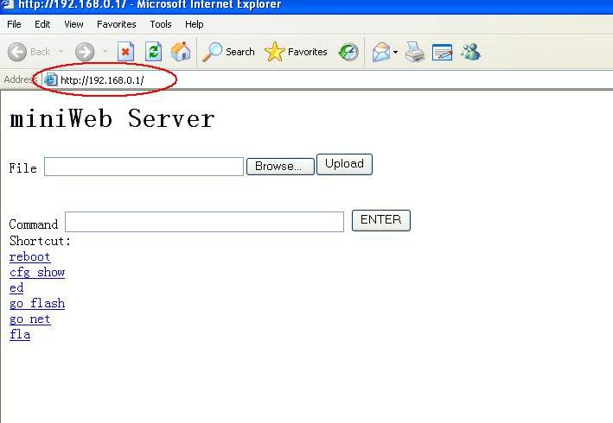

- Click “Browse “，chose the track of updated file，click “Upload”, such as following picture：
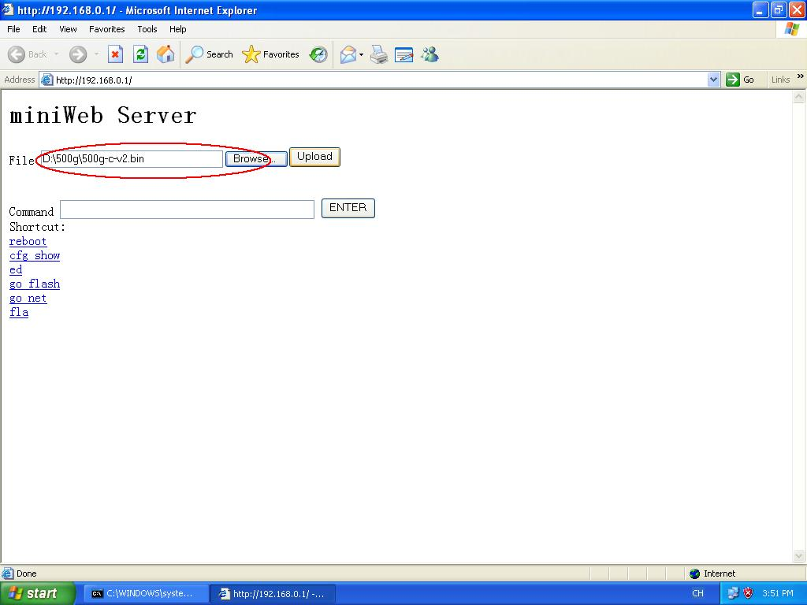

- Click “Back”，such as following picture：
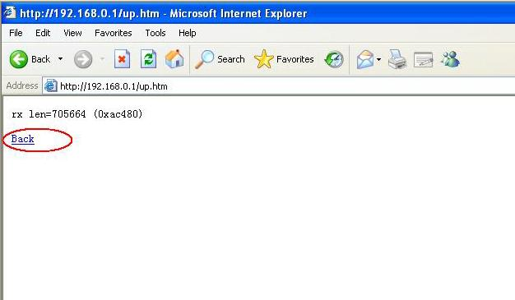

- Click “fla”，the updated would be finished about ten seconds。Such as following picture：
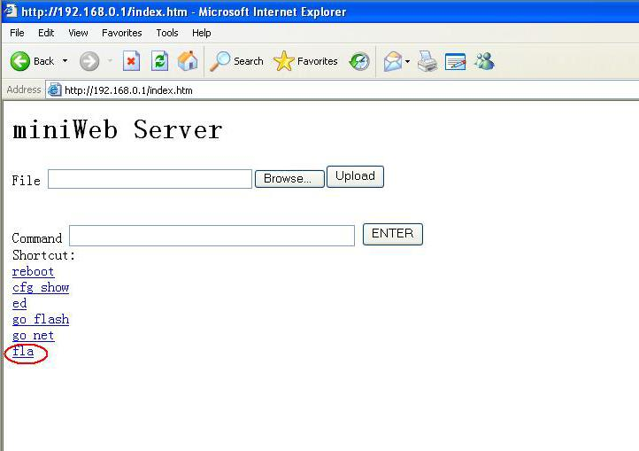

- Ten seconds later, draw out the power adapter and insert again, restart the router and input “http://192.168.0.1” in IE to check the version of the F/W. Such as following picture:：
