RM-K19 RAGING
GAMING HEADSET WITH 7 COLOR LED
USER’S MANUAL (KULLANIM KILAVUZU)
- - Thanks for choosing our gaming headset, for more information Please visit our website: www.Segment.com.tr
This headset is programmable, for more customization Please download the software program of this gaming headset from our website: www.desteksegment.com
Or Scan below QR CODE.

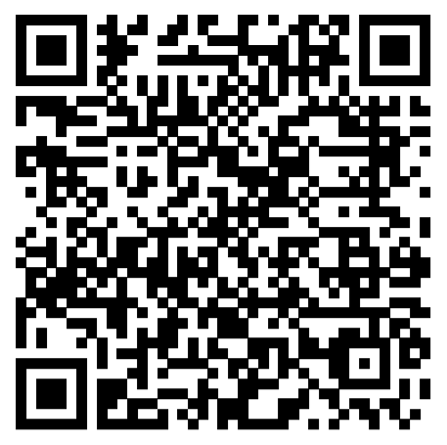

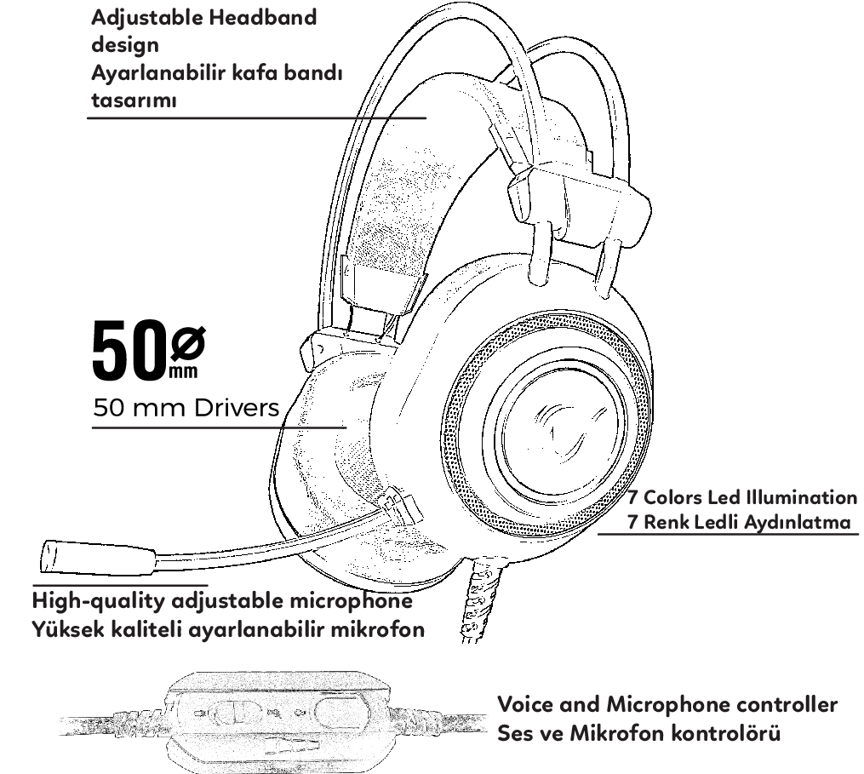
Product Drawing and Features/Ürün Çizimi ve Özellikleri / Dessin du produit et caractéristiques / Produktzeichnung und Merkmale

Technical Specifications / Teknik özellikler / Technische Spezifikationen / Spécifications techniques / Tehničke specifikacije :

Speaker size:50mm
Microphone impedance:2.2K
Impedance:16Ω+15%
Directionality:omni-directional
Sensitivety:117DB+3DB
Cable length:2.2m
Frequency range:20-20KHz
LED Working voltage:USB 5V
Microphone:Microphone 6.0x2.7mm
Working Current:<200mA
Microphone sensitivity:42±3DB
Headset jack:3.5mm+USB
//////////////////////////////////////////////////////////////////////////////////////////////////
Hoparlör boyutu: 50mm
Mikrofon empedansı: 2.2K
Empedans: 16Ω +% 15
Yönü: yönlü
Sensitivety: 117DB + 3DB
Kablo uzunluğu: 2.2m
Frekans aralığı: 20-20KHz
LED Çalışma voltajı: USB 5V
Mikrofon: Mikrofon 6.0x2.7mm
Çalışma akımı: <200ma
Mikrofon duyarlılığı: 42 ± 3DB
Kulaklık girişi: 3.5mm + USB
//////////////////////////////////////////////////////////////////////////////////////////////////
Taille des haut-parleurs: 50mm
Impédance du microphone: 2.2K
Impédance: 16Ω + 15%
Directionnalité: omnidirectionnelle
Sensibilité: 117DB + 3DB
Longueur du câble: 2,2 m
Gamme de fréquence: 20-20KHz
Tension de travail de la LED: USB 5V
Microphone: Microphone 6.0x2.7mm
Courant de travail: <200mA
Sensibilité du microphone: 42 ± 3DB
Prise casque: 3.5mm + USB
//////////////////////////////////////////////////////////////////////////////////////////////////
Lautsprechergröße: 50mm
Mikrofonimpedanz: 2,2K
Impedanz: 16Ω + 15%
Direktionalität: omnidirektional
Empfindlichkeit: 117DB + 3DB
Kabellänge: 2,2 m
Frequenzbereich: 20-20 kHz
LED Arbeitsspannung: USB 5V
Mikrofon: Mikrofon 6,0 x 2,7 mm
Arbeitsstrom: <200mA
Mikrofonempfindlichkeit: 42 ± 3DB
Headset-Buchse: 3,5 mm + USB
//////////////////////////////////////////////////////////////////////////////////////////////////
Размер динамика: 50 мм
Сопротивление микрофона: 2.2K
Сопротивление: 16Ω + 15%
Направленность: всенаправленный
Sensitivety: 117 дБ + 3DB
Длина кабеля: 2,2 м
Диапазон частот: 20-20 кГц
LED Рабочее напряжение: USB 5V
Микрофон: микрофон 6.0x2.7 мм
Рабочий ток: <200 мА
Чувствительность микрофона: 42 ± 3DB
Разъем для гарнитуры: 3,5 мм + USB



